Pengembangan Model Rekognisi Objek untuk Real-Time People Counting System Berbasis Deep Learning

Abstract
An investigation has been made to predict the effects of forebody and afterbody shapes on the aerodynamic characteristics of several projectile bodies at supersonic speeds using analytical methods combined with semi-empirical design curves. The considered projectile bodies had a length-to-diameter ratio of 6.67 and included three variations of forebody shape and three variations of afterbody shape. The results, which are verified by comparison with available experimental data, indicated that the lowest drag was achieved with a cone-cylinder at the considered Mach number range. It is also shown that the drag can be reduced by boattailing the afterbody. The centre-of-pressure assumed a slightly rearward location for the ogive-cylinder configuration when compared to the configuration with boattailed afterbody where it was the most forward. With the exception of the boattailed afterbody, all the bodies indicated inherent static stability above Mach number 2 for a centre-of-gravity location at about 40% from the body nose.
Keywords: Aerodynamics, Forebody and afterbody, Next keyword, Projectile, Supersonic speed.

- Introduction
The shape of a projectile is generally selected on the basis of combined aerodynamic, guidance, and structural considerations. The choice of seeker, at supersonic speeds, careful selection of the nose and tail shapes is mandatory to ensure performance and operation of the over-all system.
Al-Obaidi [1] showed an example how to cite a journal article in press. This is a case of one author only. Al-Obaidi and Lee [2] showed an example how to cite a journal article in press. This is a case of one author only. However, Al-Obaidi et al. produced different results.
The objectives of this paper are to show how you prepare and format your paper following JESTEC template.
For this purpose, below is how to five widely used projectile shapes are investigated. The geometry and full dimensions of these projectile shapes are shown body station. The supersonic Mach number range considered is from 1.6 to 5 for zero-angle of attack.
(a) Pointed-cone cylinder. (b) Cone cylinder boat-tail (4º).
Fig. 1. Investigated shapes of projectiles (Geometry and dimensions).
- Prediction of Aerodynamic Coefficients
Analytical methods and design charts used for the prediction of zero-lift drag normal-force-curve slope while the design charts are produced from semi-empirical characteristics are adapted from Refs. [1, 4-6] and converted to numerical data, as outlined in Appendix A.
  - Zero-lift drag coefficient C_{D0}
The total zero-lift drag coefficient of the body is usually considered to be of three components; friction drag, wave drag, and base drag as shown in Eq. (1). These different components are further discussed in the following sub-sections.
$C_{D_{0}}=C_{D_{fr}}+C_{D_{w}}+C_{D_{b}}$ (1)
2.1.1. Friction drag coefficient
For fully-turbulent and compressible flow, the friction coefficient is given by Eq. (2) [6, 7]
$C_{D_{fr}}=\frac{0.455(\log_{10}{\operatorname{Re}{)^{-2.58}}}}{(1+0.21M^{2})^{0.467}}\frac{S_{wet}}{S_{ref}}$ (2)

2.1.2. Wave drag coefficient
The main contribution to the wave drag arises from nose and afterbody. The magnitude of the wave drag depends primarily on the Mach number, the shape and body is simply the summation of the nose and afterbody wave drags
The wave drag of pointed cone-cylinder (C_{Dw})_{cone} and pointed ogive-cylinder (C_{Dw})_{ogive} can be obtained from Fig. A-1 (Appendix A) as a function of nose fineness ratio λ_{N}, and Mach number. For blunted cone-cylinder the wave drag bluntness D₀ using Eq. (4) [2, 4, 7]
  - Normal-force-curve slope C_{Nα}
The total normal-force-curve slope of nose-cylinder-boattail body is determined by the summation of the normal-force-curve slopes of the nose (with the effect of cylindrical part) and afterbody.
${C_{N}}_{a} = {\left({C_{N}}_{a}\right)}_{N} + {\left({C_{N}}_{a}\right)}_{BT}$ (7)
where (C_{Nα})_{cone} is the normal-force-curve slope of pointed cone with$β/λ_{N}^{'}$ and
- Computer Programme: Validation and Verification
To ensure the validity and accuracy of the calculations, the results are compared to typical projectile configurations (as shown in Figs. 2 and 3) are selected for this purpose. The specifications of the models and test conditions are shown in Table 1.
Table 1. Test model Specifications and test conditions.
 | Model No. 1 [8] | Model No. 2 [9]
Configuration Type | Cone-cylinder | Ogive-cylinder
Body Diameter, d (inches) | 1 | 6
Reference length, L_{ref} | d | d
Testing angle of attack (deg.) | 0 – 6 | 0
Figure 2 shows that at low angles of attack the normal force coefficients are in excellent agreement with the experimental data. The figure also shows that the current results are closer (average percentage error less than 0.5%) to the experimental data than those predicted analytically (average percentage error about 6%) by Saadi [9].
Fig. 2. Variation of normal force vs. angle of attack at M = 1.77.
At low angles of attack the normal force coefficients are in excellent agreement with the experimental data as shown in Fig. 3. This is expected due to the assumption of small angle of attack. The figure also shows that the current results are closer (average percentage error less than 0.5%) to the experimental data than those predicted analytically (average percentage error about 6%) by Saadi et al. [10]. This is expected as the analytical methods .
Fig. 3. Variation of normal force vs. angle of attack at M = 1.77.
- Results and Discussion
The prediction of the aerodynamic coefficients of the investigated projectiles shown in Fig. 1 was carried using the methods and the computer programme described above. The effects of forebody and afterbody shapes on the aerodynamics at supersonic speeds are analysed in this paper.
  - Effect of forebody
Figure 4(a) shows the effect of nose shape on C_{D0} with cylindrical afterbody as a function of Mach number. The drag of cone-cylinder combination was the lowest at the considered Mach numbers. It is clear that the bluntness of nose causes the drag to increase.
For conical, ogival, and blunted cone forebody shapes, an inherent static stability occurs for a centre-of-gravity location of about 40% body length at Mach number above around 1.6, 1.8 and 2 respectively. Such a centre-of-gravity location may not be difficult to achieve with a projectile [11].
  - Effect of afterbody
For the projectile configuration comprising conical forebody and boattail, the effect of boattail shape on the drag is shown in Fig. 5(a) as a function of Mach number. For that the higher the angle of boattail the lower is the drag.
- Conclusions
An investigation has been made of the effects of forebody and afterbody shapes of a curves. Some concluding observations from the investigation are given below.
- A pointed cone-cylinder produced the lowest drag at the considered Mach number, and the highest drag was produced by the blunted cone-cylinder.
- Configurations with boattail have higher wave drag but appreciably lower base drag with a resultant decrease of total drag. The decrease of the boattail angle increases the base drag but reduced the projectile wave drag with a resultant decrease of the total drag.
Nomenclatures

C_{BT} | Boattail factor
d | Body diameter, m
x_{cp} | Centre-of-pressure location measured from the nose apex, m
Greek Symbols
α | Angle of attack, deg.
β | Mach number parameter, $\sqrt{M^{2}-1}$
θ | Semi-vertex angle of the conical nose (Fig. 1), rad.
Abbreviations
ISA | International Standard Atmosphere
JESTEC | Journal of Engineering Science and Technology
NACA | National Advisory Committee for Aeronautics
WHO | World Health Organization
References
- Al-Obaidi, A.S.M. (2021). This is how to cite a journal article with one author. Journal of Engineering Science and Technology, 17(2), 21-29.
- Al-Obaidi, A.S.M.; and Lee, C.N. (2021). This is how to cite a journal article with two authors. Journal of Engineering Science and Technology, 17(2), 21-29.
- Al-Obaidi, A.S.M.; Lee, C.N.; Kumar, A.S.; and Frank, C.C. (2021). This is how to cite a journal article with more than two authors and less than 5 authors. Journal of Engineering Science and Technology, 17(2), 21-29.
- Al-Obaidi, A.S.M.; Kumar, A.S.; Autho1; A.A.; Author2, B.B.; Author3, C.C.; and Author4, E.E. (2022). This is how to cite a journal article with more than 5 authors. Journal of Engineering Science and Technology, 17(2), 21-29.
- Al-Obaidi, A.S.M.; and Lee, C.N. (in press). This is how to cite a journal article in press. Journal of Engineering Science and Technology..
- Al-Obaidi, A.S.M. (2018). This is how to cite proceedings/presented conference papers. Proceedings of the 1st Conference on Power, Manufacturing, and Materials (CPMM2018), Penang, Malaysia, 1-9.
- Al-Obaidi, A.S.M.; Lee, C.N.; Kumar, A.S.; and Frank, C.C. (2018). This is how to cite a textbook. McGraw Hill Book Company, Inc.
- Al-Obaidi, A.S.M.; and Frank, C.C. (2018). This is how to cite a chapter in a textbook. In Author3, C.C.; and Author4, E.E. (Eds.), Advances in education. McGraw Hill Book Company, Inc.
- Saadi, B.M. (2010). This is how to cite a dissertation/thesis. PhD Thesis, Department of Mechanical Engineering, University of London.
- Saadi, B.M. (2010). This is how to cite a dissertation/thesis. MSc dissertation, Department of Mechanical Engineering, University of London.
- Saadi, B.M.; Lee, C.N.; Kumar, A.S.; and Frank, C.C. (2018). This is how to cite a report. NACA Report No. 6623.
- Kumar, B.A.; and Verma, C.-J. (2018). This is how to cite an electronic reference or internet source. Retrieved October 5, 2020, from https://www.pinterest.com/pin/part-1--459789443214558480/

Appendix A
Computer Programme
A. 1. Introduction
A computer code, for the prediction of projectile aerodynamic characteristics as a empirical methods presented in section 2.
The computer programme can serve two main purposes: firstly, in the design provide a complete picture of the projectile over its whole flight.
A. 2. Programme Structure and Description of Subroutines
Fortran-77 language is used in programming the prediction methods. Each estimation convenience. The main flow chart of the programme is shown in Fig. A-1.
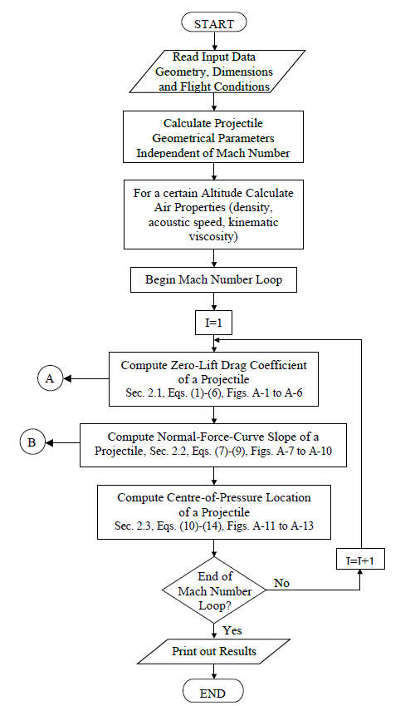
Fig. A-1. Main flow chart of the computer programme used in this study.

